Part 1 installer Automatique sans des ficher additionnelle (*.accdb, *.sql ….)

Fichier->Ajoute->Ajoute Nouveau Projet-> Autres Types de Projet

Autres Types de Projet->Assistant Installation

*********************************************************************

Part 2 installer Manuel avec des ficher additionnelle (*.accdb, *.sql ….)

Public cn As OleDbConnection

Public cmd As OleDbCommand

Public dr As OleDbDataReader

Public bl As Boolean

Public st As String

Public NBD As String

cn = New OleDbConnection("Provider=Microsoft.ACE.OLEDB.12.0; Data Source = " & nbd)

Declare a variable NBD in module To stock string fuction

Create class installer

Click right in project name under solution

1. Ajoute->Composant->Generale->Fichier de configuration de l’application

Add a tag appSetting in the config file under configuratin tag

<?xml version="1.0" encoding="utf-8" ?>

<configuration>

<appSettings>

<add key="NomBD" value="Mondb.accdb"/>

<add key="NomServeur" value=""/>

</appSettings>

Mondb is the name of the original database

NBD create that varible in connection module

Add to project references in .Net

System.configuration

Import these classes in main window code

Imports System.Configuration

Imports System.Configuration.ConfigurationManager

Private Sub Produit_Load(ByVal sender As System.Object, ByVal e As System.EventArgs) Handles MyBase.Load

NBD = ConfigurationManager.AppSettings.Get("NomBD")

End Sub

Now after we finish this all we add an istaller msi

Fichier->Ajoute->Ajoute Nouveau Projet-> Autres Types de Projet

Autres Types de Projet->Assistant Installation

Add a raccouri icon

And name it

Now we add a zone text type A in interface utilisateur

Ad these adjustment IN PROPERTY

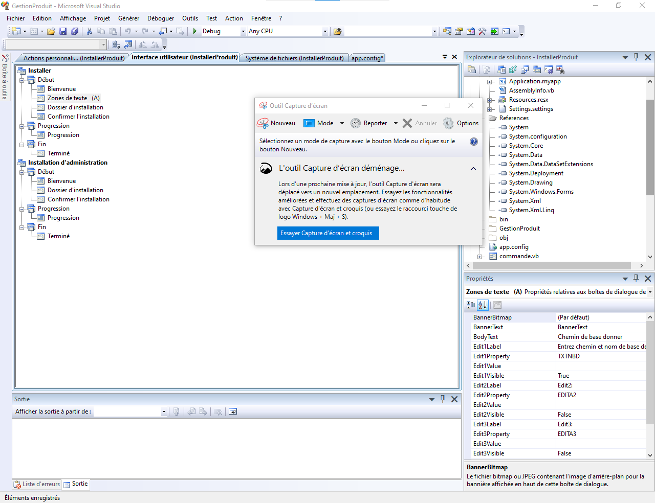

NOW goto Action personalize

Add new action in Installer

Go to his properties add espace required in the first of each /

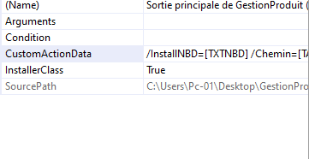

/InstallNBD=[TXTNBD] /Chemin="[TARGETDIR]\"

1. Ajoute->Composant->Generale->Classe Installer

Add to his code

Imports System.ComponentModel

Imports System.Configuration.Install

Public Class Installer1

Public Sub New()

MyBase.New()

InitializeComponent()

End Sub

Public Overrides Sub Install(ByVal stateSaver As System.Collections.IDictionary)

Dim nombd As String = Me.Context.Parameters.Item("InstallNBD")

Dim chemin As String = Me.Context.Parameters.Item("Chemin")

Dim fn As String = chemin & "GestionProduits.exe.config"

Dim xmldoc As New Xml.XmlDocument

Dim xmlnoeud As Xml.XmlNode

xmldoc.Load(fn)

For Each xmlnoeud In xmldoc.Item("configuration").Item("appSettings")

If xmlnoeud.Name = "add" Then

If xmlnoeud.Attributes.GetNamedItem("key").Value = "Nombd" Then

xmlnoeud.Attributes.GetNamedItem("value").Value = nombd

End If

End If

Next

xmldoc.Save(fn)

MyBase.Install(stateSaver)

End Sub

End Class